**Name: Jason Li**

**Component Safari**

**Instructions:**  
Locate each of these components in your trainer PC. Take and insert a picture or find one online. Provide a brief description of what the component does.

**Case: provides structure to the SU, come in with different form.**

**Power Supply: provide power to the SU.**

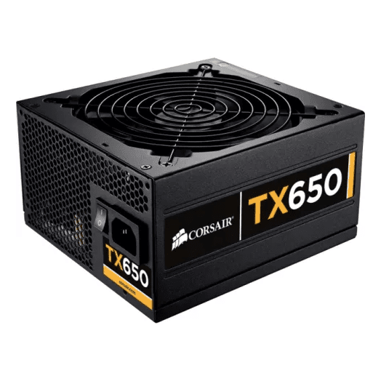

**Motherboard: The backbone of the SU, where everything plugs too.**

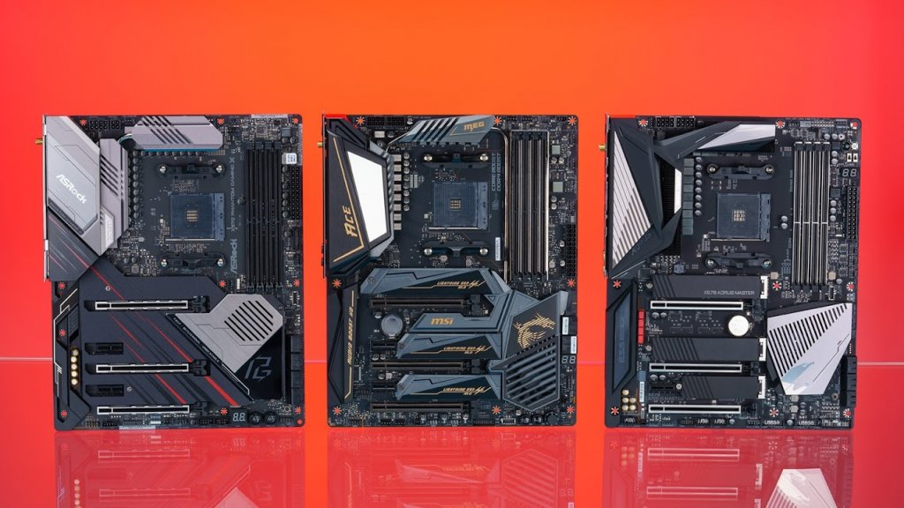

**Processor: Responsible for running any app and system**

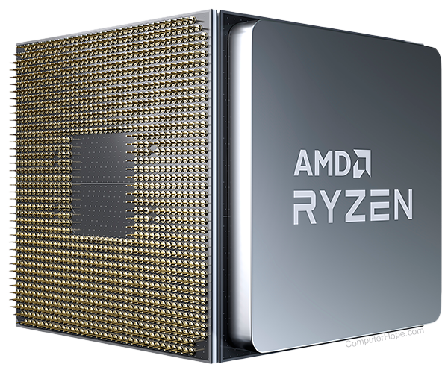

**CPU Cooler: Cools the CPU**

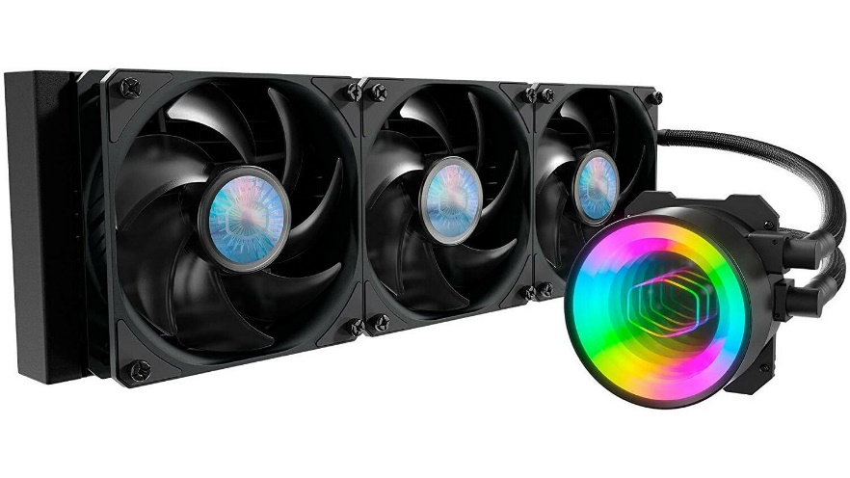

**RAM: Work storage for CPU, don’t storage anything without power**

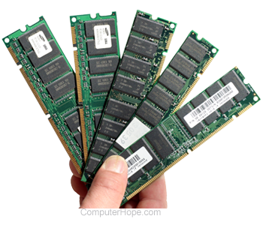

**Expansion Card: GPU, Sound, and Network upgrades etc**

**Hard Drive: Stores data**

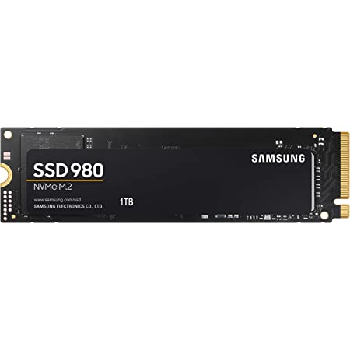

**Optical Drive: CD, DVD, etc**

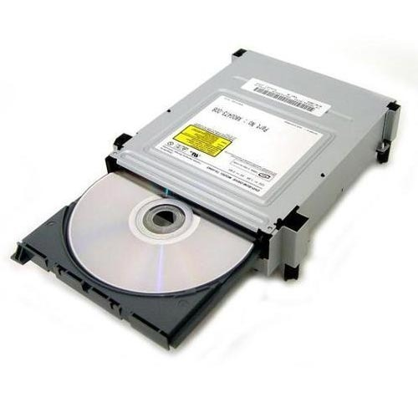

**Case Fan: Help airflow aka help cooling**

